[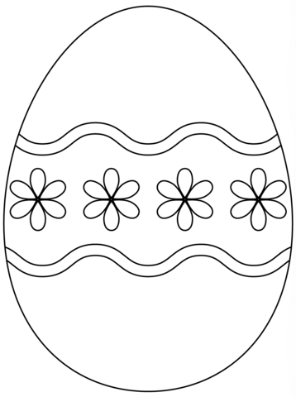](http://www.supercoloring.com/coloring-pages/easter-egg-with-simple-flower-pattern?version=print)