[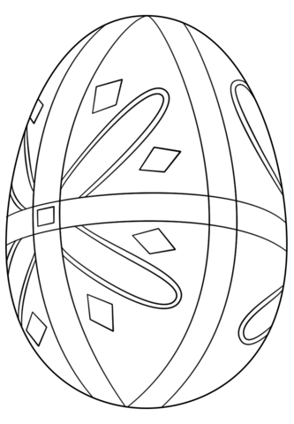](http://www.supercoloring.com/coloring-pages/pysanka-easter-egg?version=print)