[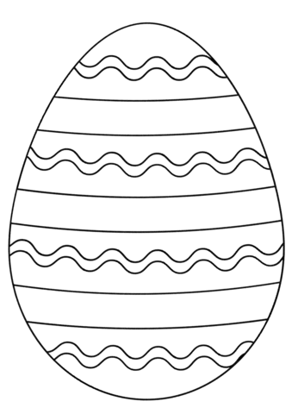](http://www.supercoloring.com/coloring-pages/easter-egg?version=print)